SWIFT CSCF Compliance for Log360
Automate SWIFT CSCF compliance and fortify cybersecurity resilience for financial institutions with Log360.
Region: International | Type: Financial Services, Industry Standard, Incident Management | Category: Compliance | Pricing: Free

Overview
The SWIFT CSCF compliance extension in Log360 helps organizations meet the SWIFT Customer Security Controls Framework, a mandatory security standard issued by SWIFT for all connected financial institutions requiring 25 baseline cybersecurity controls by providing centralized log management, real-time threat detection, and network activity monitoring. The platform supports SWIFT CSCF requirements for network isolation, logical access and MFA enforcement, credential security, malware protection, security event logging, vulnerability scanning, database integrity, and cyber incident response.
For SWIFT Environment Isolation and Network Protection, Log360 monitors network device logs, firewall events, and attack reports to detect boundary violations and unauthorized access to the SWIFT environment. To address Logical Access Control and MFA Enforcement, the platform tracks AD logon events, Entra ID MFA activity, user management changes, and Windows authentication reports to evidence mandatory access controls. The extension also supports Credential and Password Security by providing capabilities that monitors password audit events, AD password management, failed logon attempts, and account changes to evidence password policy enforcement.

Key Features
- System Hardening and Patch Management: Log360 monitors software update events, program inventory, registry changes, and configuration modifications to track patch compliance.
- Malware Protection and Threat Detection: Log360 ingests threat detection events from Trend Micro, FireEye, and McAfee to provide unified malware monitoring.
- Security Event Logging and Audit Trail: Log360 centralizes database audit logs, AD activity, and Windows EventLog records to enable daily review and automated alerting on suspicious activity.
- Automated Compliance Auditing and Independent Assessment Support: Log360 provides pre-built reporting templates mapped to SWIFT CSCF control objectives, streamlining the collection of technical evidence required for annual self-attestations and external regulatory audits.

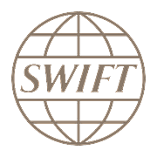
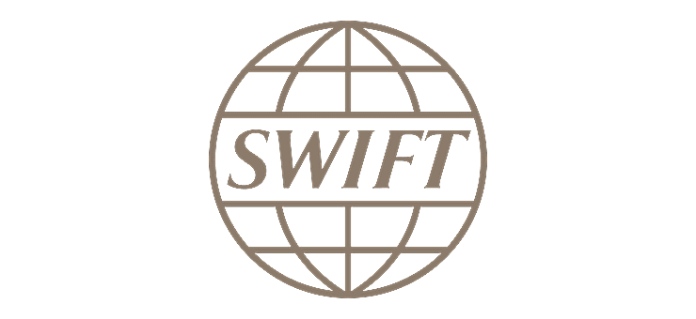
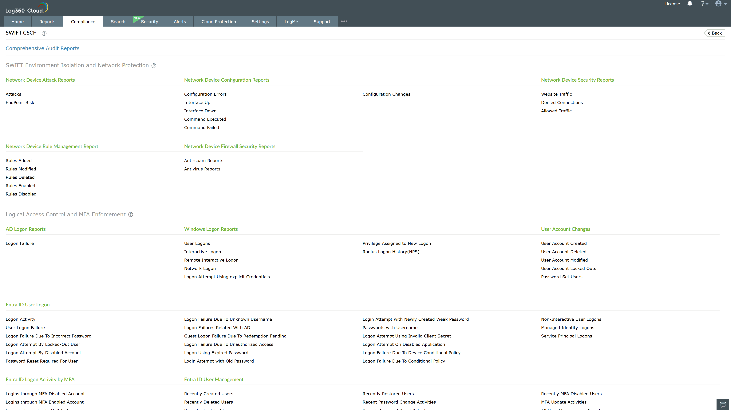
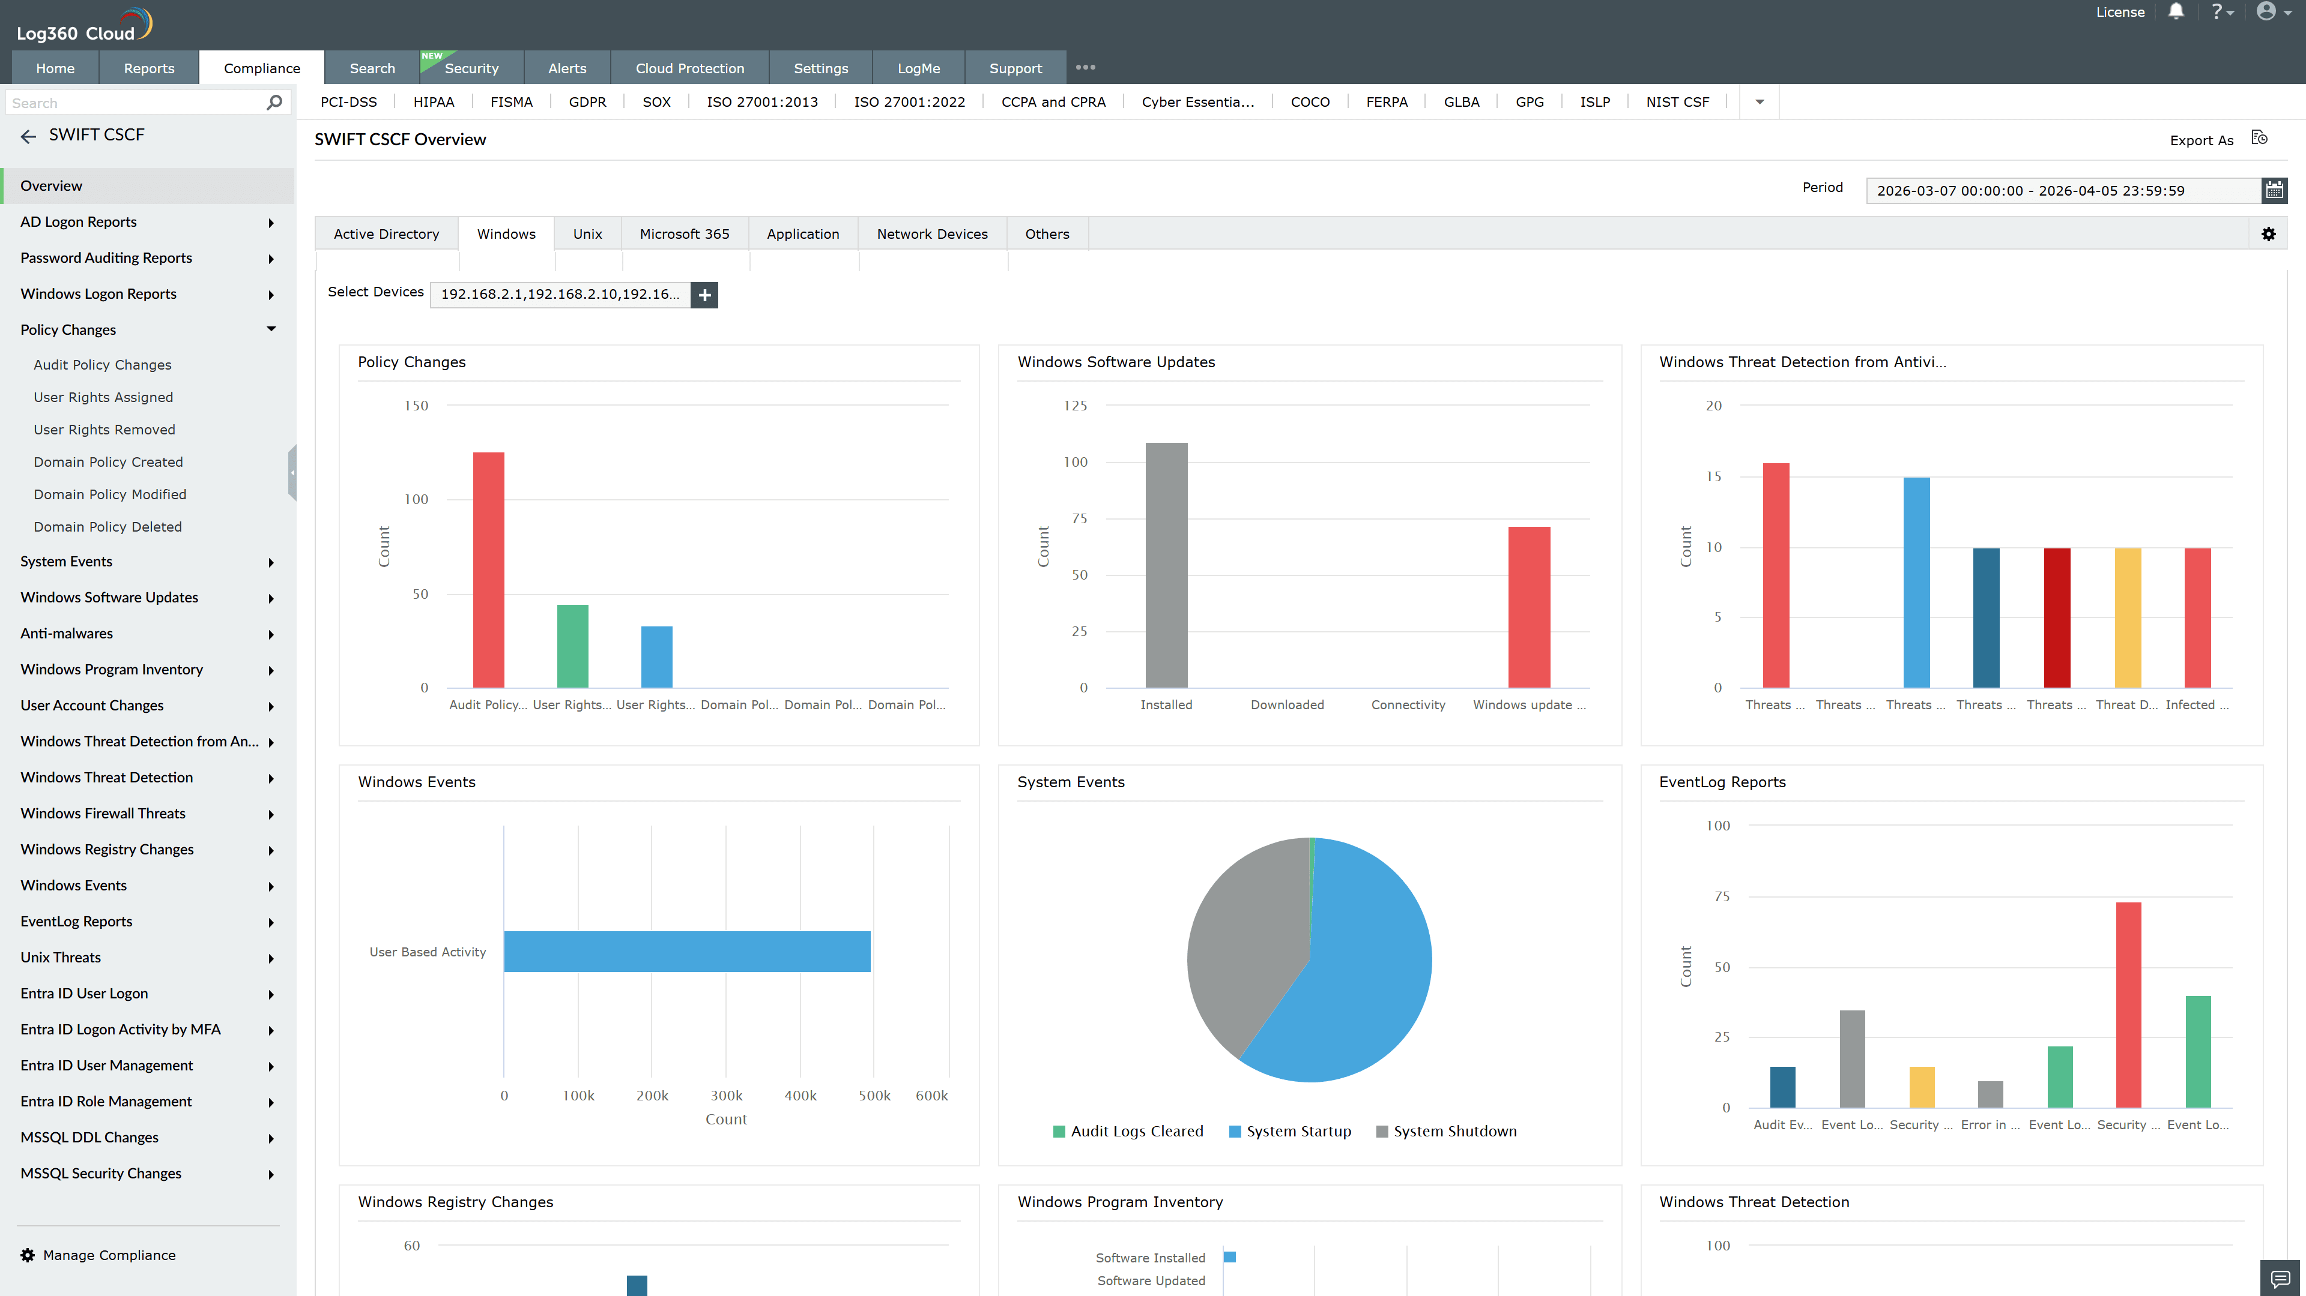
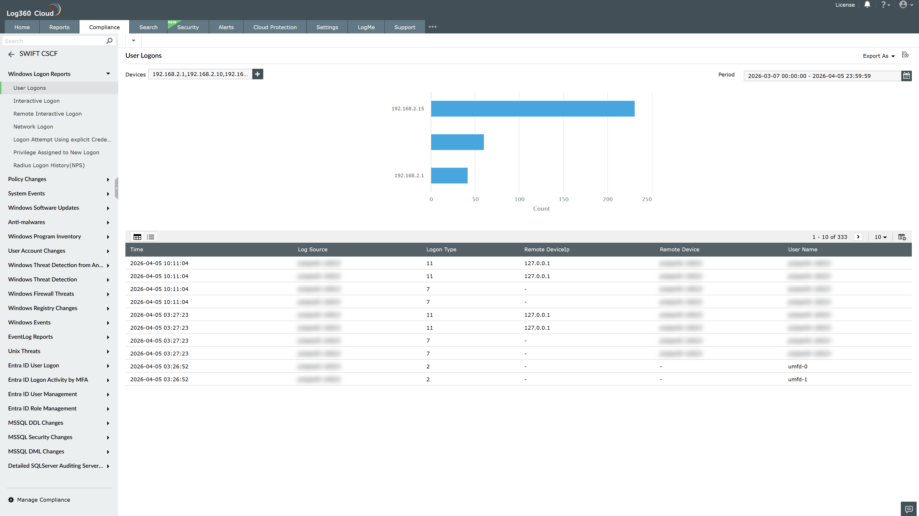
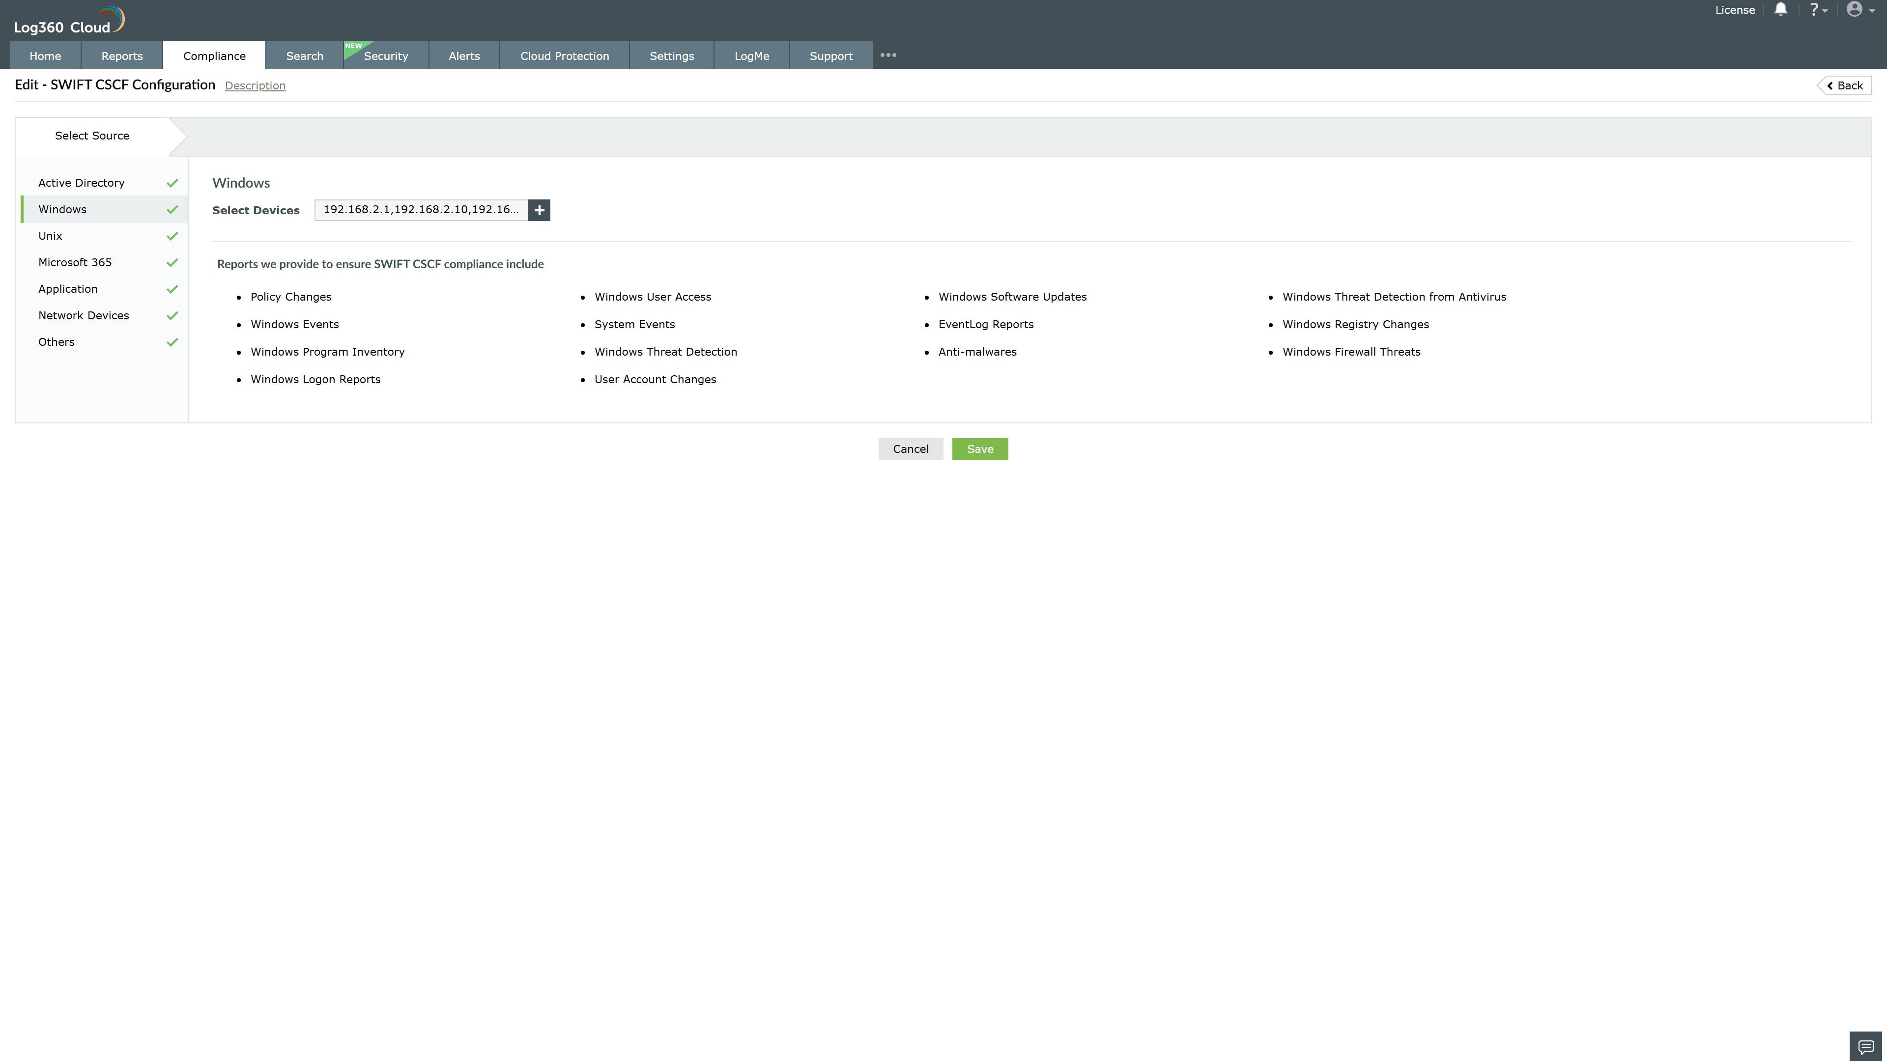
Valid Submission : Yes
Supported Editions : Free, Basic, Standard, Professional, MSSP
Help Document : https://www.manageengine.com/log-management/help/integrations/compliance-extensions.html
Help Video : Not provided
Tags : Log360, Compliance, Privacy monitoring, Data privacy, Regulatory compliance
Supported DCs : US, IN, JP, CA, AU, UK and EU
Privacy Policy:
Terms of Service:
Release Notes:
Predefined reports for the SWIFT CSCF.

